MOTION SICKNESS MITIGATION THROUGH AUDIO AND VISUAL MODALITY PROTOTYPE

N.M. Yusof 1,2*, M.I. Sulaiman1,2, J. Karjanto^{1,2}, M.Z. Hassan^{1,2}, S. Sulaiman³ and Z.M. Jawi4

¹Faculty of Mechanical Technology and Engineering, Universiti Teknikal Malaysia Melaka, Hang Tuah Jaya, 76100 Durian Tunggal, Melaka, Malaysia.

²Centre for Advanced Research on Energy, Universiti Teknikal Malaysia Melaka, Hang Tuah Jaya, 76100 Durian Tunggal, Melaka, Malaysia.

³Faculty of Engineering Technology Universiti Tun Hussein Onn Malaysia, Pagoh Higher Education Hub, 84600 Pagoh, Muar, Johor, Malaysia.

⁴Vehicle Safety and Biomechanics Centre (VSB), Malaysian Institute of Road Safety Research (MIROS), 125-135, Jalan TKS 1, 43000 Kajang, Selangor, Malaysia.

Corresponding Author’s Email: nidzamuddin@utem.edu.my

Article History: Received 04 March; Revised 12 June 2025; Accepted 28 June 2025

ABSTRACT: Engaging in non-driving-related activities such as reading, watching movies, and web browsing while in a moving vehicle is known to contribute to motion sickness. Hence, future users cannot fully utilise future autonomous vehicles if motion sickness exists. Two modality prototypes (audio and visual were developed by applying the concept of situation awareness. The audio prototype provides voice direction about the vehicle’s future turns, allowing users to receive manoeuvre information while focusing on their activities. The visual prototype lets users see what is happening in front of the moving vehicle while reading. This study was conducted to assess these two prototypes. Eighteen (18) participants took part in this study. The study used a real road experiment using the Wizard of Oz method, which involved two conditions: with and without a prototype. Motion sickness and situation awareness were assessed. The results show that both prototypes reduce motion sickness and increase situational awareness while maintaining a similar mental workload.

KEYWORDS: Motion sickness; Autonomous Vehicle; Audio Modality; Visual Modality

INTRODUCTION

Normal cars require human operation to control their movements and trajectories to navigate between destinations. But different companies have consistently worked on these technologies to enhance them for autonomous vehicle development [1], [2], [3]. Autonomous vehicle technology removes human interaction to control the vehicle’s manoeuvres [4]. The technology enables users or passengers to do non-driving-related activities (NDRA) whilst traveling [5], [6], [7], [8]. Examples of non-driving activities are working on a laptop, reading a book, listening to music, etc. According to previous studies, the potential users of the autonomous vehicle will also do non-driving related activities and trust the technology [9], [10], [11]. However, performing NDRA requires focus removal from the surroundings and tends to induce motion sickness [12], [13].

Motion sickness is a form of sickness due to exposure to motion stimulus that has multiple symptoms, from headache and nausea to fatigue, and finally, vomiting [14]. There are various theories explaining the causes of motion sickness, among which the sensory conflict theory is one. This theory suggests that the human sensory organs (e.g., otolith organs, visual sensors, and somatosensory receptors) were not synchronised [15]. For instance, a passenger in a moving vehicle engages in a reading activity. The body’s somatic and vestibular sensory receptors sense vibration and forces as the vehicle moves, and that is transmitted to the brain to send signals of a moving motion. Whereas the visual sensors are constrained to the non-moving reading material, which signals a fixed motion. According to the theory, the mismatch between these sensors contributes to motion sickness.

Moreover, the misalignment of sensory systems was also added to by the lack of anticipation in the vehicle’s trajectory [16], [17], [18]. Previous studies demonstrate that raising situation awareness can enhance anticipation, leading to a decrease in motion sickness symptoms [18], [19]. Situation awareness is the ability to keep track of what is happening around them, gather the information as it is happening, and predict what may happen in the short term. In terms of vehicle riding, situation awareness is the capacity of passengers to acquire the situation information from the environment of the vehicle, including other road users’ behaviour, vehicle’s trajectories, road’s condition, etc., and to use the information to predict the coming time [19]. The shape of a projectile will be chosen given a combined aerodynamic, guidance, and structural analysis The choice of seeker, at supersonic speeds, carefully selecting the nose and tail shapes, is mandatory to ensure performance and operation of the overall system.

The research has already identified a number of prototypes and solutions to improve situation awareness and reduce motion sickness, depending on modalities. There were three primary modalities investigated: visual [20], [21], [22], haptic [23], and audio [18], [24], [25]. The objective of this study was to develop and trial the prototype using audio and haptic modalities to enhance situation consciousness and decrease motion sickness in a real road environment.

2.0 PROTOTYPE
The primary objectives were to enhance the situational awareness of autonomous vehicle passengers while experiencing the NDRA to minimize motion sickness.

2.1 Audio Modality Prototype
The audio prototype in this study is a device that plays a directional voice telling the moving vehicle’s future manoeuvre to the users engaging in NDRA. This prototype consists of several components, as listed in Table 1.

Table 1: Main material for audio prototype
Material | Description
Speaker | 100W – 160W, 12V, 6.5 inch
SMD Uno microprocessor | Atmel Atmega328P
Audio amplifier | TDA7297, 12V
Micro SD card module | SPI ICSP interface
Micro SD card | 8GB

The speakers and controller circuit setup can be seen in Figure 1(a) and (b), respectively. Two (2) different circuits were used to minimise the possibility of any error that might appear, especially when the vehicle was set to be in stereo mode. Each circuit plays a different sound direction on each side of the speaker (i.e., when the vehicle was about to turn left, only the left circuit was turned on to play the “left” sound on the left speaker).

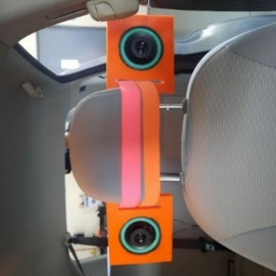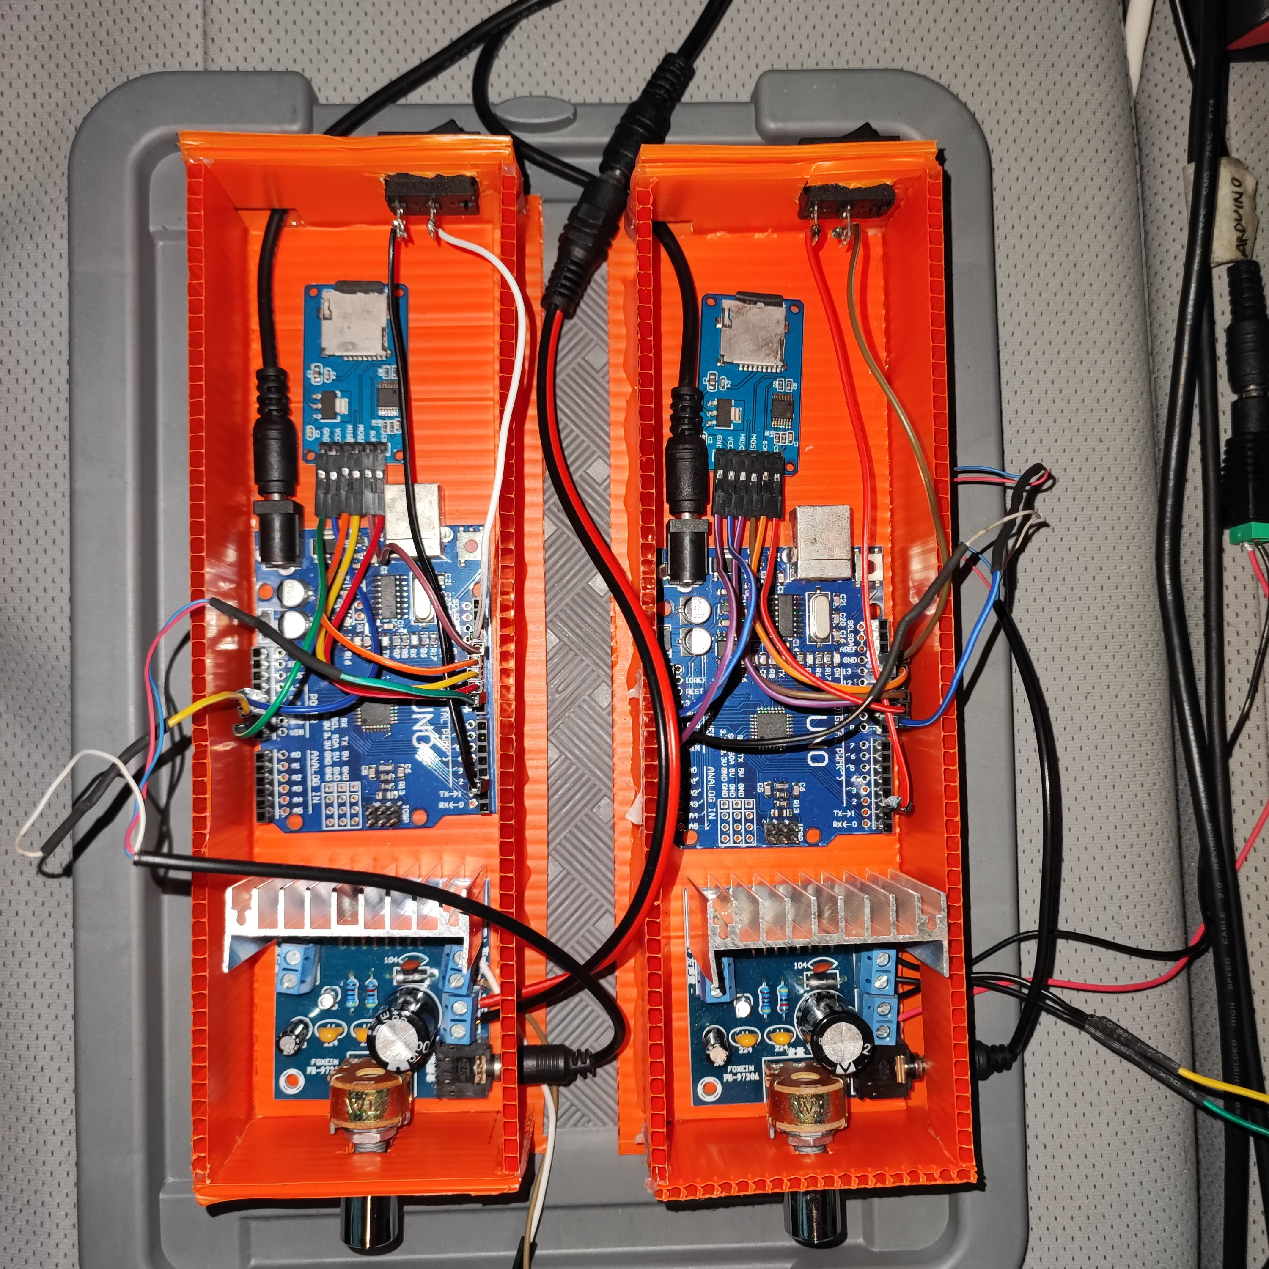
Figure 1: Setup of (a) the audio prototype in stereo mode; (b) the controller circuit

To operate this prototype, the Interactive Wizard switches on the left or right circuit two (2) seconds before every turn. The circuit will then play a directional sound in the user’s native language (“left, left, left” or “right, right, right”) on either the left or right speaker. The sound played was a self-recorded voice. The audio files were converted into 8-bit resolution, a sampling rate of 16,000 Hz, mono audio channels, and unsigned 8-bit for the PCM format. The files were then saved in .wav format before they were transferred to two (2) different SD cards, each for the left and right circuits.

The coding for the microprocessor was prepared and uploaded to the SMD Uno. The coding used an extra library named ‘TMRpcm’, enabling the microprocessor to read the audio file from an SD card. The audio recording was saved on the SD card to summarise the codes. The SD card was then inserted into the SD card module connected to the microprocessor before it could read the audio file. As the switch is turned on, the microprocessor plays the audio through the speaker until the audio ends before the switch is turned off.

A 9V DC power supply drives the circuit of a microprocessor. To boost the audio volume, an assembled audio amplifier with TDA7297 as its base was connected between the microprocessor and the speaker using a 3.5mm audio jack. This amplifier allowed the audio volume to be adjusted to a specific level. A 12V DC power supply powered the amplifier. An appropriate converter was connected to all power supplies, linking them to the vehicle’s power source. The assembled circuit is illustrated in Figure 2.
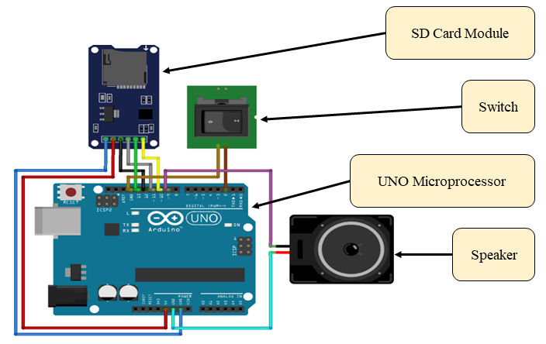
Figure 2: Illustration of the audio prototype circuit

2.2 Visual Modality Prototype
The visual prototype is a device that can display a transparent reading text overlaid on the moving vehicle’s front view. The purpose of this prototype was to improve the user’s situational awareness and, in principle, reduce motion sickness. By having this prototype, users can monitor what is going on in front of the moving car while they are reading. The vehicle’s front view was live-streamed using a wired webcam to ensure minimal latency between the real and displayed views. The arrangement of the visual prototype and webcam inside the instrumented car is illustrated in Figure 3(a) and (b).

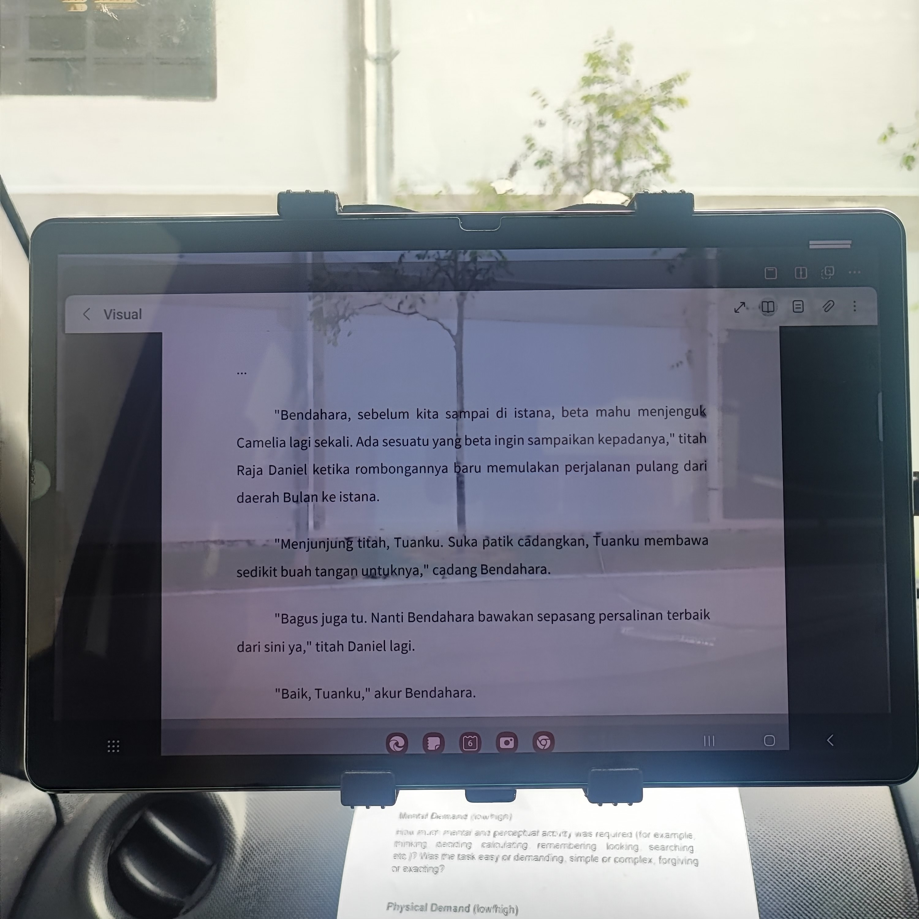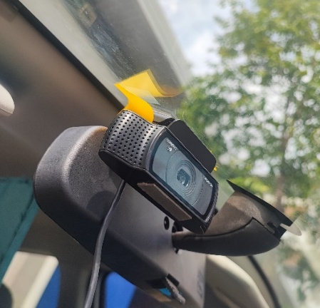
Figure 3: The setup of the: (a) Visual prototype; (b) Webcam

This prototype enables users to adjust the opacity of the reading material and text size according to their preferences. The opacity of the reading material can be adjusted from 50% (most transparent) to 100% (fully opaque). However, the opacity was limited to 90% to ensure that the user could still get the information on the background of the reading material. The opacity of the reading material at 50% and 90% can be seen in Figure 4(a) and (b), respectively.

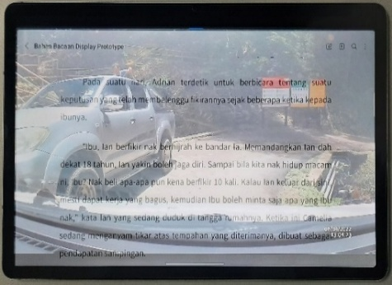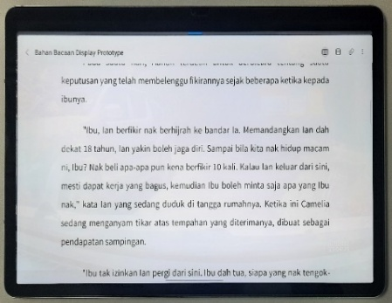
Figure 4: The opacity at: (a) 50%; (b) 90%

The text size of the reading material can be changed by using the zoom features, available from 60% to 600%. However, the most suitable range of the reading material is from 100% to 180% only (the largest text size without being scrolled horizontally). The text size at the zoom level of 100% and 180% is shown in Figure 5(a) and (b).

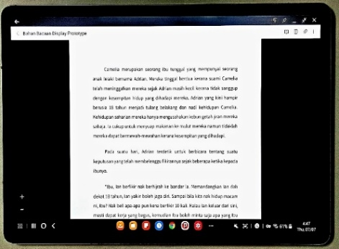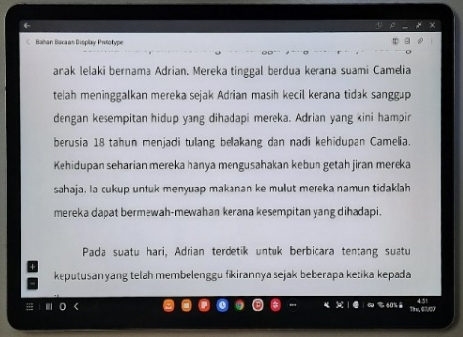
Figure 5: The text size at a zoom level of: (a) 100%; (b) 180%

3.0 METHODOLOGY

3.1 Experimental Design
A total of eighteen (18) participants (12 males and 6 females; age range 20 to 26 years; mean = 22.38 years, SD = 1.64 years) participated in this experiment. A completely counterbalanced order (3! = 6 orders) was used to balance the learning effect. Participants were exposed to three (3) experimental conditions: control condition (CC), audio condition (AC), and visual condition (VC). To prevent any signs of motion sickness originating from the last session, a minimum of three (3) days between conditions was maintained. Participants in this study were also free from vestibular disorders. Participants were instructed not to drink alcohol (in the last 24 hours) or eat heavy meals (in the previous 2 hours) before the experiment session.

The main equipment used was the instrumented vehicle [26], a customized subcompact car, Perodua Myvi (see Figure 6. The instrumented vehicle applies the Wizard of Oz method [27] to imitate the autonomous vehicle riding experience. In this method, participants acted as passengers in autonomous vehicles, performing the reading activity as a non-driving-related task. A Driving Wizard was appointed to drive the vehicle in a defensive driving style [28], [29], [30]. The participants were assisted in gathering the data by an interactive Wizard.
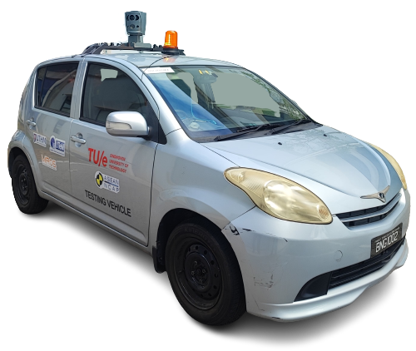
Figure 6: Instrumented vehicle

The experiment was conducted at Universiti Tun Hussein Onn Malaysia (UTHM), Pagoh Campus. The route has 11 left and 12 right turns for a total of 4.2 km, taking around 10 minutes. All traffic regulations were obeyed, including the maximum speed limit of 30 km/h on straight roads. This route was designated to yield a lateral Motion Sickness Dose Value of 4.96 (mild motion sickness) [31].

The independent variable in this study was the use of the prototype, whether with or without the prototype. The dependent variables are motion sickness level, measured by the Motion Sickness Assessment Questionnaire (MSAQ) [32], situation awareness using the Situation Awareness Rating Technique (SART) [33], NASA Task Load Index (NASA-TLX) [34], mental workload using the Rating Scale Mental Effort (RSME) [35], Reading Performance and prototype assessment using the User Experience Questionnaire (UEQ-Short) [36].

3.2 Procedure
Figure 7 shows that all sessions were divided into three (3) phases: Before, During, and After Experiment. In the Before Experiment phase, the Interactive Wizard conducted a briefing session, showing participants how the experiment would take place, instructions on cautions, as well as details for the operation of the prototypes.
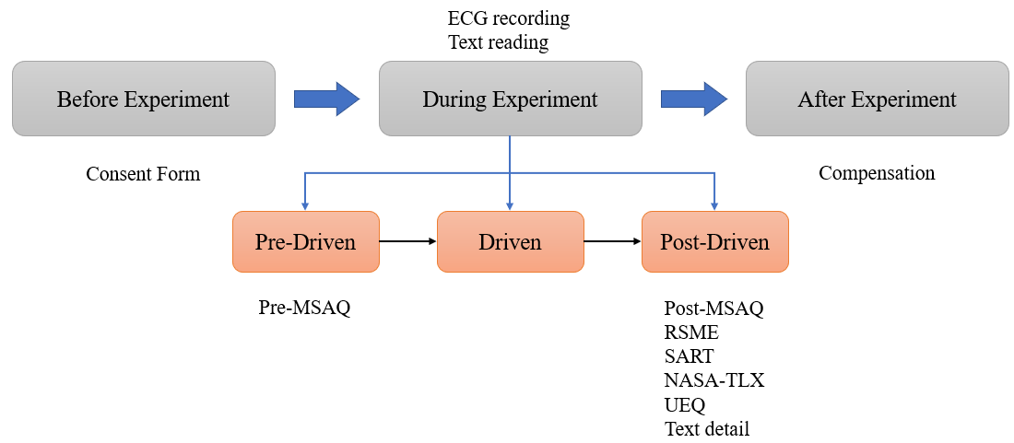
Figure 7: The summary of the experimental procedure

Three stages were divided into the During-Experiment phase. The first stage (pre-Driven) was a 5-minute familiarisation stage, during which the vehicle was stationary. During this stage, the participants answered the pre-Driven MSAQ. Next was the vehicle drive on the planned test route in the second stage (Driven). After the route ended, the 5-minute resting period started (post-Driven), where the vehicle was kept stationary again. At that point, the rest of the questionnaires (post-Driven MSAQ, SART, RSME, and UEQ) were answered. Participants were debriefed during the After-Experiment phase. The participants received the compensation they were accorded for participating in the study. Furthermore, participants have the right to cancel the experiment at any time.

There is a reading section in the experimental scenario in which the participants had to be seated in the front passenger position and read the reading material on an electronic tablet. Different conditions provide different reading material to keep participants interested in the reading activity. The setup and prototype position of the tablet inside the instrumented vehicle is shown in Figure 8.

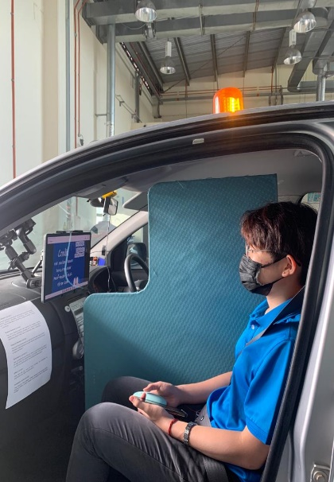
Figure 8: Setup of the reading tablet position inside the Instrumented Vehicle

4.0 RESULTS AND DISCUSSION

4.1 Motion Sickness Assessment
The average scores for the MSAQ construct are summarized in Table 2. MSAQ results were obtained from the difference between the post-driven and pre-driven phases, hence the labelling Δ in each MSAQ construct (i.e., ΔG = post-driven gastrointestinal - pre-driven gastrointestinal).

Table 2: Average score of MSAQ in all conditions
Component | Control Condition | Audio Condition | Visual Condition
Δ Gastrointestinal (G) | 18.71 | 8.64 | 9.26
Δ Central (C) | 22.57 | 13.09 | 13.09
Δ Peripheral (P) | 8.97 | 4.12 | 4.53
Δ Sopite (S)* | 21.35 | 15.28 | 17.13
Δ Overall (O) | 18.75 | 10.84 | 11.50
*Indicates statistically significant difference, p<0.05

The MSAQ was analysed using one-way repeated measures ANOVA. This was done to establish whether statistically significant differences existed between MSAQ measurements in three conditions: control (CC), audio (AC), and visual condition (VC). In an analysis of each MSAQ construct (gastrointestinal (G), central (C), peripheral (P), sopite (S), and overall (O)), Table 3 shows that these constructs were analysed separately.

Table 3: One-way repeated measures ANOVA for each MSAQ construct
MSAQ Construct | One-Way Repeated Measures ANOVA
Δ Gastrointestinal (G)* | $F\left(2,34\right)=3.45, p<0.05$, partial $η^{2}=0.17$
Δ Central (C)* | $F\left(2,34\right)=4.35, p<0.05$, partial $η^{2}=0.21$
Δ Peripheral (P) | $F\left(2,34\right)=1.69, p=0.20$, partial $η^{2}=0.09$
Δ Sopite (S)* | $F\left(2,34\right)=1.31, p=0.28$, partial $η^{2}=0.07$
Δ Overall (O)* | $F\left(2,34\right)=3.80, p<0.05$, partial $η^{2}=0.18$
*Indicates statistically significant difference, p<0.05

In the overall (ΔO) construct, the data contains no outliers, as assessed by inspecting a boxplot for values greater than 1.5 box lengths from the edge of the box. The results were also normally distributed, as assessed by Shapiro-Wilk’s test (p > 0.05). The mean MSAQ was found to be decreased from CC (mean = 19.52, SD = 14.34) to VC (mean = 11.50, SD = 8.62) to AC (mean = 10.84, SD = 10.43), in that order. In addition, Mauchly’s test of sphericity indicated that the assumption of sphericity had not been violated, X^2 (2) =2.48, p=0.29. The ΔO of the MSAQ was statistically significantly different at different conditions during the experiment sessions; F (2,34) =3.80, p<0.05, partial η^2=0.18. Figure 9 illustrates the decrease in MSAQ mean across the three (3) conditions.

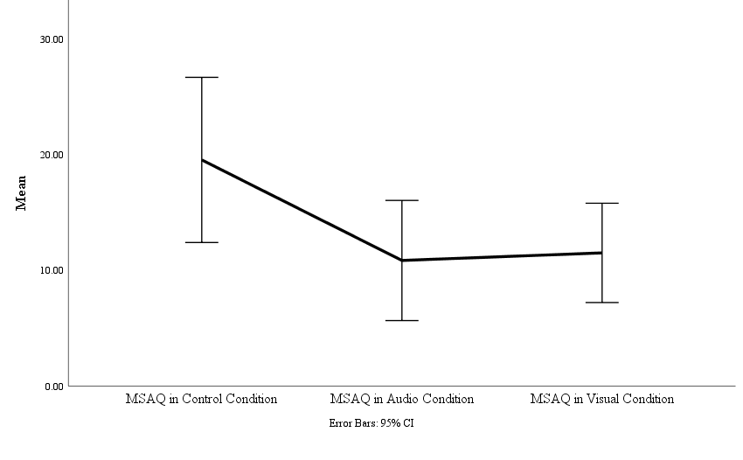
Figure 9: Overall MSAQ score mean of Control Condition, Visual Condition, and Audio Condition

The motion sickness assessment, measured through the MSAQ, shows a statistically significant difference between conditions when analysed using one-way repeated measures ANOVA, especially in the overall construct (see Table 3). All the symptoms, in addition to the peripheral and sopite symptoms, exhibit a statistically significant difference in gastrointestinal- and central-related symptoms between each condition. This marked decrease in those constructs indicates that the prototypes can reduce stomach sickness, queasiness (which are gastrointestinal symptoms), and light-headedness and dizziness (which are central-related symptoms). As shown in the average overall measure of MSAQ decreased from 18.75 (Control Condition, CC) to 11.50 (Visual Condition, VC) and 10.84 (Audio Condition, AC), along with other constructs, significantly. These score reductions indicate that both prototypes mitigate most of the motion sickness symptoms found during reading in the driven autonomous vehicle. Moreover, MSAQ scores aligned well with previous studies of the prevention of motion sickness by prototypes from audio modality [18], [24], [25], and visual modality [18], [24], [25] and visual modality [22], [37], [38], [39], [40].

4.2 Situation Awareness
The situation awareness for this experiment was measured using the Situation Awareness Rating Technique (SART). The average scores for all SART constructs can be seen in Table 4.

Table 4: Average scores for SART constructs
Component | Control Condition | Audio Condition | Visual Condition
Understanding (U) | 12.47 | 15.16 | 15.00
Demand (D) | 10.95 | 9.63 | 9.84
Supply (S) | 15.74 | 18.26 | 19.68
Situation Awareness (SA) | 17.26 | 23.79 | 24.84

SART analysis used one-way repeated measures ANOVA. The SART constructs (U, D, S, and SA) were examined independently, and their results are presented in Table 5. It is found that there were no outliers in the data from the U and SA constructs as assessed by inspection of a boxplot. But D and S constructs exhibited small outliers in the 1.5 box length range. They were retained in the analysis, as they were regarded as actual data (outliers from an extreme data point and not from an error of measurement). The SART score was normally distributed by Shapiro-Wilk’s test (p > 0.05). Mauchly’s test of sphericity provided evidence that all constructs have met the assumption of sphericity. Aside from the D construct, the difference between the baseline and the development (p< 0.05) of SART scores was significant after the implementation of prototypes. The overall SART scores expanded from the control condition (mean = 17.06, SD = 2.36), audio condition (mean = 23.83, SD = 1.38) and finally to the visual condition (mean = 25.22, SD = 2.17) (refer toFigure 10). A statistically significant increase in SART occurs in the control and visual conditions, with a mean difference of 8.17, p < 0.05.

Table 5: One-way repeated measures ANOVA for SART constructs
SART Construct | One-Way Repeated Measures ANOVA
Understanding (U)* | $F\left(2,34\right)=5.54, p<0.05$, partial $η^{2}=0.25$
Demand (D) | $F\left(2,34\right)=0.89, p=0.42$, partial $η^{2}=0.05$
Supply (S)* | $F\left(2,34\right)=7.67, p<0.05$, partial $η^{2}=0.31$
Situation Awareness (SA)* | $F\left(2,34\right)=6.33, p<0.05$, partial $η^{2}=0.27$
*Indicates statistically significant difference, p<0.05

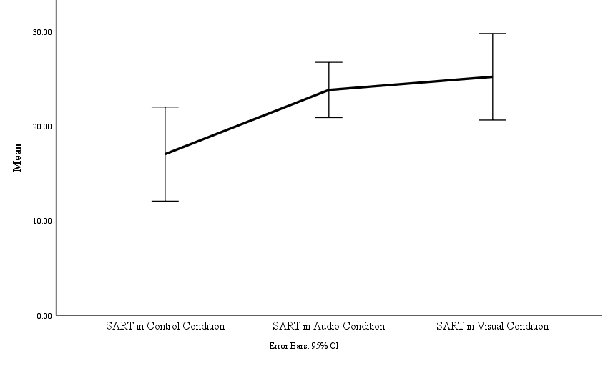
Figure 10: Mean differences in SART scores

In terms of situational awareness, the findings indicate that the prototypes successfully fulfil the main objective of enhancing situational awareness when interacting with NDRA. The SART results reveal that all constructs, with the exception of the demand construct, exhibited statistically significant differences, showing an increase from CC to prototype conditions (refer to Table 4). This outcome implies that the demand construct, which pertains to the rate of situational change, situation complexity, and the number of variables requiring attention, did not show a substantial difference between conditions with and without prototypes. Furthermore, overall SART scores demonstrate that participants’ situational awareness in VC is marginally superior compared to AC. The visual prototype's application in conveying future trajectory information to bolster situational awareness proved to be slightly more effective than its audio counterpart [41], [42].

In addition, the use of audio cues in autonomous vehicles has been shown to enhance situational awareness when combined with visual aids. A previous study demonstrated that the auditory signal increased participants' awareness of the vehicle's future trajectory [43]. Interview findings from this research indicated that participants utilized the audio cue to prepare their bodies by tensing their muscles prior to any turns, which helped minimize body sway and head roll angle. This information proved beneficial as they were engaged in reading activities. The signal enables users to concentrate on their reading material while remaining aware of their surroundings. The management of body sway and head roll angle contributes to a reduction in motion sickness [44], [45], [46].

The data provided by both prototypes, where the audio version offered an auditory turning signal and the visual version displayed a live-streamed view of the vehicle in front, sufficiently enables passengers to be informed about present and upcoming scenarios. Nonetheless, utilizing these prototypes might introduce additional demands on users, particularly concerning cognitive processes, as they must concentrate on various components at once (such as interpreting written material and processing information from the prototypes). Hence, mental effort and workload were assessed using suitable methods.

4.3 Mental Effort and Workload
Two questionnaires were utilized to assess mental effort and workload: The Rating Scale Mental Effort (RSME) and the NASA Task Load Index (NASA-TLX). The mean scores obtained from the RSME for CC, AC, and VC were 80, 84, and 89, respectively. To analyse any significant differences in scores across various conditions involving different prototypes, a Friedman test was conducted on the RSME data. The results showed that RSME scores remained consistent across all conditions (median = 80). Still, the results were not statistically significantly different between each condition, $X^{2}\left(2\right)=0.62, p=0.74.$ The average scores of each construct of NASA-TLX are presented in Table 6.

Table 6: Average scores of NASA-TLX for each construct
NASA-TLX Construct | Control Condition | Audio Condition | Visual Condition
Mental Demand (MD) | 277.22 | 245.00 | 282.22
Physical Demand (PD) | 63.33 | 39.44 | 27.78
Temporal Demand (TD) | 102.50 | 183.33 | 145.28
Performance (P) | 65.56 | 64.44 | 73.33
Effort (E) | 203.06 | 230.00 | 215.83
Frustration Level (FL) | 78.61 | 109.72 | 107.22
Overall (O) | 52.68 | 57.02 | 55.67

One-way repeated measures ANOVA was applied to determine significant changes in each construct between conditions. No outliers were found in the data except for physical demand (PD), performance (P), and frustration level (FL). The outliers were retained for the remainder of the analysis because they were not due to measurement error, as they represented genuinely uncommon data. The results also show that they were normally distributed, as assessed by Shapiro-Wilk’s test (p > 0.05). Mauchly’s test of sphericity indicated that the assumption of sphericity had not been violated (p > 0.05). Overall, the usage of prototypes does not lead to any statistically significant changes in the NASA-TLX score over the three conditions, except for the temporal demand. The results of the analysis can be seen in Table 7.

Table 7: One-way repeated measures ANOVA for NASA-TLX
NASA-TLX Construct | One-Way Repeated Measures ANOVA
Mental Demand (MD) | $F\left(2,34\right)=0.44, p=0.65$, partial $η^{2}=0.03$
Physical Demand (PD) | $F\left(2,34\right)=1.53, p=0.23$, partial $η^{2}=0.08$
Temporal Demand (TD)* | $F\left(2,34\right)=4.38, p<0.05$, partial $η^{2}=0.21$
Performance (P) | $F\left(2,34\right)=0.16, p=0.85$, partial $η^{2}=0.01$
Effort (E) | $F\left(2,34\right)=0.39, p=0.68$, partial $η^{2}=0.02$
Frustration Level (FL) | $F\left(2,34\right)=0.34, p=0.71$, partial $η^{2}=0.02$
Overall (O) | $F\left(2,34\right)=0.23, p=0.80$, partial $η^{2}=0.01$
*Indicates statistically significant difference, p<0.05

The average scores for NASA-TLX demonstrate an increase, rising from CC (52.68) to VC (55.67) and AC (57.02). The median value of RSME was 80, suggesting that users' mental effort fell within the range of considerable to great effort categories. Nevertheless, as prototypes do not have a notable impact on users' mental effort during reading tasks, no direct correlation can be drawn regarding differences in motion sickness or situational awareness. These findings align with previous research indicating that mental effort does not play a role in the onset of motion sickness [47], [48].

4.4 Reading Performance
The assessment of reading performance was conducted by tallying the total number of correct answers, which were then categorized into different levels of focus: 0 correct answers indicated "Not Focus," 1 correct answer signified "Slightly Focus," 2 correct answers represented "Moderate Focus," and 3 correct answers denoted "Focus." The findings are presented in Table 8.

Table 8: Results of reading performance
Group | Condition (number of responses)
Group | Control | Audio | Visual
Focus | 14 | 15 | 13
Moderate Focus | 4 | 2 | 4
Slightly Focus | 0 | 1 | 1
Not Focus | 0 | 0 | 0

To explore potential variations in focus levels based on the use of different prototype modalities during the riding session, a Friedman test was performed. The analysis revealed that the focus level remained stable at the highest category (median = Focus group); however, the differences observed were not statistically significant, X²(2) = 0.26, p = 0.88$.$

The findings revealed a consistent pattern, predominantly among participants categorized in the Focus and Moderate Focus groups. Given that the median score fell within the Focus group, it indicated that users-maintained concentration on the reading materials with minimal variation across different conditions. Nevertheless, there was one participant who was classified in the Slightly Focus group for both AC and VC. This suggests that some individuals struggled to sustain their attention at optimal levels due to the additional information presented through the prototypes. While most participants exhibited no issues with focus, a number were still distracted by the prototypes. This aligns with previous research indicating that a quiet and less distracting environment enhances reading performance [49], [50], [51].

4.5 Prototype Assessment
Participants evaluated the prototypes based on their subjective experiences using the User Experience Questionnaire (UEQ). As presented in Table 9, the means, standard deviations (SD), and calculated Cronbach’s α for both audio and visual prototypes are detailed. The mean values for each construct reflect favorable outcomes, exceeding a threshold of 0.8. Although all constructs display high reliability with Cronbach’s α values above 0.6, an acceptable level for exploratory studies [52], the novelty construct for the visual prototype and the dependability and novelty constructs for the audio prototype did not meet this standard. It is important to note that in studies with smaller sample sizes, such as this one, the validity of Cronbach’s α results is weaker compared to those derived from samples of at least 100 participants [53], [54].

Table 9: UEQ results for audio and visual prototypes
UEQ Constructs | n | Audio Prototype |  |  | Visual Prototype
UEQ Constructs | n | Mean | SD | Cronbach’s α | Mean | SD | Cronbach’s α
Attractiveness | 18 | 1.07 | 1.10 | 0.86 | 1.24 | 1.52 | 0.95
Perspicuity | 18 | 1.54 | 0.95 | 0.63 | 1.17 | 1.39 | 0.87
Efficiency | 18 | 1.33 | 1.02 | 0.65 | 1.28 | 1.39 | 0.84
Dependability | 18 | 1.36 | 0.96 | 0.57 | 1.60 | 1.13 | 0.69
Stimulation | 18 | 0.92 | 1.23 | 0.91 | 1.68 | 1.22 | 0.85
Novelty | 18 | 1.11 | 1.12 | 0.54 | 1.44 | 0.97 | 0.31
Note: The rating is a 7-point Likert scale, from -3(horribly bad) to +3 (extremely good)

The UEQ findings indicate that the majority of constructs exceeded average benchmarks, whereas a few were categorized as good or below-average (refer to Figure 11). A two-sample T-test, which assumes unequal variances and employs an alpha level of 0.05, reveals no significant differences between the constructs of the two prototypes.

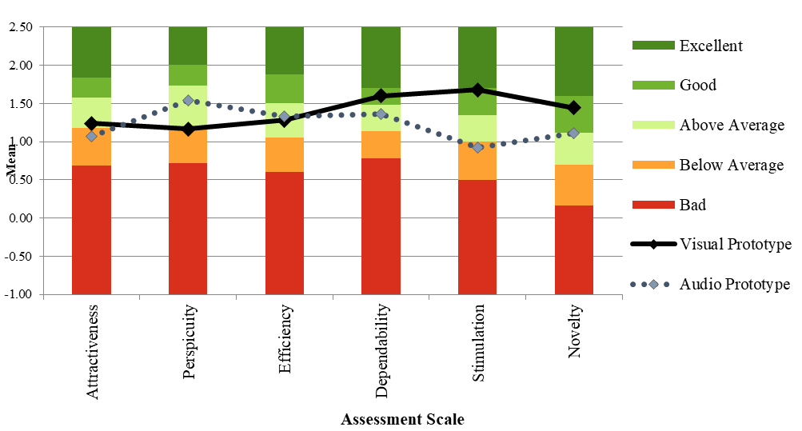
Figure 11: Visualization of the UEQ benchmark

The findings indicate that participants had a favourable response to both prototypes, achieving average ratings exceeding 0.8. This implies that the prototypes successfully met their goals of enhancing situation awareness, thereby alleviating overall motion sickness. This assertion is supported by the comprehensive MSAQ results, which showed scores of 18.75 for the CC prototype, reduced to 11.50 and 10.84 for the VC and AC prototypes, respectively (see Table 2). Additionally, SART outcomes reveal an improvement in participants' situation awareness, increasing from 17.26 in CC to 23.79 and 24.84 in AC and VC, respectively (refer to Table 2. Moreover, a benchmarking evaluation was conducted to assess the initial indicators of market viability for the prototypes [55]. As illustrated in Table 9 and Figure 11, it can be inferred that these prototypes possess potential for market entry since most constructs demonstrate Above-Average quality. Nonetheless, certain enhancements are required, particularly for those constructs categorized as Below-Average. For instance, improvements in the audio prototype’s attractiveness and stimulation are essential to better engage potential consumers. Nevertheless, the primary aim of these prototypes in this research was to present the vehicle's future trajectory in a manner that does not distract users while facilitating their engagement in NDRA).

5.0 CONCLUSION
The audio prototype successfully mitigated motion sickness and enhanced user situational awareness. These findings indicate that the underlying concept of this prototype could be integrated into forthcoming autonomous vehicle technologies. According to the data collected from this study, users experienced improved situation awareness and reduced motion sickness without incurring any extra mental effort while operating the prototype, even during reading tasks. Nonetheless, enhancements are required, as evidenced by the UEQ results, which reflect a below-average score in the stimulation construct. This aspect pertains to user motivation for utilizing the prototype; the low ratings suggest that it may not gain traction in the marketplace upon release. Given that the experiment involved a limited sample size, further research with a larger participant group is necessary to substantiate these findings.

ACKNOWLEDGEMENTS
The authors acknowledge the Malaysian Institute of Road Safety Research (MIROS), Universiti Tun Hussein Onn Malaysia (UTHM), and Universiti Teknikal Malaysia Melaka (UTeM) for the funding and support that made this vital research viable and effective. This research is fully supported by an international grant, ANCHOR/2020/FKM-CARE/A00031. The authors declare that the contents of this article have not been published previously. All the authors have contributed to the work described, read, and approved the contents for publication in this manuscript. The study was approved by the ethics committee of the UTHM (UTHM.RMC.100-9/139(5)).

REFERENCES
[1] M. Herger, “2020 Disengagement Reports from California,” The Last Driver License Holder…. Accessed: Aug. 16, 2024. [Online]. Available: https://thelastdriverlicenseholder.com/2021/02/09/2020-disengagement-reports-from-california/

[2] Q. Tariq, “Cyberjaya now home to Malaysia’s first autonomous vehicle testing route | The Star,” The Star. Accessed: Jan. 31, 2022. [Online]. Available: https://www.thestar.com.my/tech/tech-news/2020/12/23/cyberjaya-now-home-to-malaysias-first-autonomous-vehicle-testing-route

[3] J. Rivers, “Overview Of Technology In Autonomous Cars: What, Why, When & How?” Level Five Supplies.

[4] W. Payre, S. Birrell, and A. M. Parkes, “Although autonomous cars are not yet manufactured, their acceptance already is,” Theor Issues Ergon Sci, vol. 22, no. 5, pp. 567–580, Sep. 2021, doi: 10.1080/1463922X.2020.1836284.

[5] B. Pfleging, M. Rang, and N. Broy, “Investigating user needs for non-driving-related activities during automated driving,” in Proceedings of the 15th International Conference on Mobile and Ubiquitous Multimedia, New York, NY, USA: ACM, Dec. 2016, pp. 91–99. doi: 10.1145/3012709.3012735.

[6] S. H. Yoon and Y. G. Ji, “Non-driving-related tasks, workload, and takeover performance in highly automated driving contexts,” Transp Res Part F Traffic Psychol Behav, vol. 60, pp. 620–631, Jan. 2019, doi: 10.1016/j.trf.2018.11.015.

[7] T. Hecht, E. Darlagiannis, and K. Bengler, “Non-driving Related Activities in Automated Driving – An Online Survey Investigating User Needs.,” in Human Systems Engineering and Design II (IHSED 2019), vol. 1026, T. Ahram, W. Karwowski, S. Pickl, and R. Taiar, Eds., in Advances in Intelligent Systems and Computing, vol. 1026. , Cham: Springer International Publishing, 2019, pp. 182–188. doi: https://doi.org/10.1007/978-3-030-27928-8_28.

[8] B. Pfleging and A. Schmidt, “(Non-) Driving-Related Activities in the Car: Defining Driver Activities for Manual and Automated Driving,” in CHI ’15: Proceedings of the 33rd Annual ACM Conference on Human Factors in Computing Systems, Seoul: ACM Digital Library, Apr. 2015, pp. 5–8.

[9] Z. Wadud and F. Y. Huda, “Fully automated vehicles: the use of travel time and its association with intention to use,” Proceedings of the Institution of Civil Engineers - Transport, vol. 176, no. 3, pp. 127–141, Jun. 2023, doi: 10.1680/jtran.18.00134.

[10] B. Schoettle and M. Sivak, “A survey of public opinion about connected vehicles in the U.S., the U.K., and Australia,” in 2014 International Conference on Connected Vehicles and Expo (ICCVE), IEEE, Nov. 2014, pp. 687–692. doi: 10.1109/ICCVE.2014.7297637.

[11] C. Wilson, D. Gyi, A. Morris, R. Bateman, and H. Tanaka, “Non-Driving Related tasks and journey types for future autonomous vehicle owners,” Transp Res Part F Traffic Psychol Behav, vol. 85, pp. 150–160, Feb. 2022, doi: 10.1016/j.trf.2022.01.004.

[12] M. L. H. Jones, V. C. Le, S. M. Ebert, K. H. Sienko, M. P. Reed, and J. R. Sayer, “Motion sickness in passenger vehicles during test track operations,” Ergonomics, vol. 62, no. 10, pp. 1357–1371, Oct. 2019, doi: 10.1080/00140139.2019.1632938.

[13] M. I. Sulaiman et al., “Non-Driving Related Activities Inside an Automated Vehicle Among Malaysia Passengers,” Automotive Experiences, vol. 6, no. 3, pp. 452–465, 2023.
[14] B. Cohen, M. Dai, S. B. Yakushin, and C. Cho, “The neural basis of motion sickness,” J Neurophysiol, vol. 121, no. 3, pp. 973–982, Mar. 2019, doi: 10.1152/jn.00674.2018.

[15] J. T. Reason, “Motion Sickness Adaptation: A Neural Mismatch Model,” J R Soc Med, vol. 71, no. 11, pp. 819–829, Nov. 1978, doi: 10.1177/014107687807101109.

[16] M. E. Levine, R. M. Stern, and K. L. Koch, “Enhanced perceptions of control and predictability reduce motion-induced nausea and gastric dysrhythmia,” Exp Brain Res, vol. 232, no. 8, pp. 2675–2684, Aug. 2014, doi: 10.1007/s00221-014-3950-9.

[17] P. J. Feenstra, J. E. Bos, and R. N. H. W. van Gent, “A visual display enhancing comfort by counteracting airsickness,” Displays, vol. 32, no. 4, pp. 194–200, Oct. 2011, doi: 10.1016/j.displa.2010.11.002.

[18] O. X. Kuiper, J. E. Bos, C. Diels, and E. A. Schmidt, “Knowing what’s coming: Anticipatory audio cues can mitigate motion sickness,” Appl Ergon, vol. 85, p. 103068, May 2020, doi: 10.1016/j.apergo.2020.103068.

[19] M. R. Endsley, “Situation Awareness,” in Handbook of Human Factors and Ergonomics, Wiley, 2021, pp. 434–455. doi: 10.1002/9781119636113.ch17.

[20] R. Li, N. Peterson, H. J. Walter, R. Rath, C. Curry, and T. A. Stoffregen, “Real-time visual feedback about postural activity increases postural instability and visually induced motion sickness,” Gait Posture, vol. 65, pp. 251–255, Sep. 2018, doi: 10.1016/j.gaitpost.2018.08.005.
[21] J. Karjanto, N. Md. Yusof, C. Wang, J. Terken, F. Delbressine, and M. Rauterberg, “The effect of peripheral visual feedforward system in enhancing situation awareness and mitigating motion sickness in fully automated driving,” Transp Res Part F Traffic Psychol Behav, vol. 58, pp. 678–692, Oct. 2018, doi: 10.1016/j.trf.2018.06.046.

[22] A. Meschtscherjakov, S. Strumegger, and S. Trösterer, “Bubble Margin: Motion Sickness Prevention While Reading on Smartphones in Vehicles,” 2019, pp. 660–677. doi: 10.1007/978-3-030-29384-0_39.

[23] N. Md. Yusof, J. Karjanto, J. M. B. Terken, F. L. M. Delbressine, and G. W. M. Rauterberg, “Gaining Situation Awareness through a Vibrotactile Display to Mitigate Motion Sickness in Fully-Automated Driving Cars,” International Journal of Automotive and Mechanical Engineering, vol. 17, no. 1, pp. 7771–7783, Apr. 2020, doi: 10.15282/ijame.17.1.2020.23.0578.

[24] P. Larsson, J. Maculewicz, J. Fagerlönn, and M. Lachmann, “Auditory Displays for Automated Driving — Challenges and Opportunities,” in Proceedings of the 25th International Conference on Auditory Display (ICAD 2019), Newcastle upon Tyne, United Kingdom: Department of Computer and Information Sciences, Northumbria University, Jun. 2019, pp. 299–305. doi: 10.21785/icad2019.038.

[25] J. Maculewicz, P. Larsson, and J. Fagerlönn, “Intuitive and subtle motion-anticipatory auditory cues reduce motion sickness in self-driving cars,” Int J Hum Factors Ergon, vol. 8, no. 4, p. 370, 2021, doi: 10.1504/IJHFE.2021.119053.

[26] J. Karjanto et al., “The Development of an Automated Vehicle Simulator for On-Road Study,” Journal of the Society of Automotive Engineers Malaysia, vol. 5, no. 2, pp. 235–243, 2021.

[27] S. Baltodano, S. Sibi, N. Martelaro, N. Gowda, and W. Ju, “The RRADS platform: A Real Road Autonomous Driving Simulator,” in Proceedings of the 7th International Conference on Automotive User Interfaces and Interactive Vehicular Applications - AutomotiveUI ’15, New York, USA: ACM Press, 2015, pp. 281–288. doi: 10.1145/2799250.2799288.

[28] J. Karjanto et al., “The identification of Malaysian driving styles using the multidimensional driving style inventory,” MATEC Web of Conferences, vol. 90, pp. 1–14, Dec. 2017, doi: 10.1051/matecconf/20179001004.

[29] L. Oliveira, K. Proctor, C. G. Burns, and S. A. Birrell, “Driving style: How should an automated vehicle behave?” Information (Switzerland), vol. 10, no. 6, pp. 1–20, 2019, doi: 10.3390/info10060219.

[30] J. Karjanto, N. Md. Yusof, J. Terken, F. Delbressine, M. Z. Hassan, and M. Rauterberg, “Simulating autonomous driving styles: Accelerations for three road profiles,” MATEC Web of Conferences, vol. 90, pp. 1–16, Dec. 2017, doi: 10.1051/matecconf/20179001005.

[31] M. J. Griffin and M. M. Newman, “An experimental study of low-frequency motion in cars,” Proceedings of the Institution of Mechanical Engineers, Part D: Journal of Automobile Engineering, vol. 218, no. 11, pp. 1231–1238, Nov. 2004, doi: 10.1243/0954407042580093.

[32] P. J. Gianaros, E. R. Muth, J. T. Mordkoff, M. E. Levine, and R. M. Stern, “A Questionnaire for the Assessment of the Multiple Dimensions of Motion Sickness,” Aviat Space Environ Med, vol. 72, no. 2, pp. 115–119, 2001.
[33] R. M. Taylor, “Situational Awareness Rating Technique (SART): The development of a tool for aircrew systems design,” in Proceedings of the AGARD AMP Symposium on Situational Awareness in Aerospace Operations, CP478, Seuilly-sur-Seine, France: NATO AGARD, 1990.

[34] S. G. Hart and L. E. Staveland, “Development of NASA-TLX (Task Load Index): Results of Empirical and Theoretical Research,” Advances in Psychology, vol. 52, no. C, pp. 139–183, 1988, doi: 10.1016/S0166-4115(08)62386-9.

[35] G. A. Sartang, “Evaluation of Rating Scale Mental Effort (RSME) effectiveness for mental workload assessment in nurses,” 2016.

[36] M. Schrepp, A. Hinderks, and J. Thomaschewski, “Construction of a Benchmark for the User Experience Questionnaire (UEQ),” International Journal of Interactive Multimedia and Artificial Intelligence, vol. 4, no. 4, pp. 40–44, 2017, doi: 10.9781/ijimai.2017.445.

[37] E. Hanau and V. Popescu, “MotionReader,” in Proceedings of the 9th International Conference on Automotive User Interfaces and Interactive Vehicular Applications Adjunct - AutomotiveUI ’17, New York, USA: ACM Press, 2017, pp. 72–76. doi: 10.1145/3131726.3131741.

[38] M. Miksch, M. Steiner, M. Miksch, and A. Meschtscherjakov, “Motion Sickness Prevention System (MSPS),” in Adjunct Proceedings of the 8th International Conference on Automotive User Interfaces and Interactive Vehicular Applications, New York, NY, USA: ACM, Oct. 2016, pp. 147–152. doi: 10.1145/3004323.3004340.

[39] T. Sawabe et al., “Comfortable autonomous navigation based on collision prediction in blind occluded regions,” in 2015 IEEE International Conference on Vehicular Electronics and Safety (ICVES), IEEE, Nov. 2015, pp. 75–80. doi: 10.1109/ICVES.2015.7396897.

[40] Y. Tamura, T. Wada, and H. Liu, “Generating Visual Information for Motion Sickness Reduction Using a Computational Model Based on SVC Theory,” in 2023 IEEE 26th International Conference on Intelligent Transportation Systems (ITSC), IEEE, Sep. 2023, pp. 5066–5071. doi: 10.1109/ITSC57777.2023.10422244.

[41] T. Van Veen, J. Karjanto, and J. Terken, “Situation awareness in automated vehicles through proximal peripheral light signals,” AutomotiveUI 2017 - 9th International ACM Conference on Automotive User Interfaces and Interactive Vehicular Applications, Proceedings, pp. 287–292, 2017, doi: 10.1145/3122986.3122993.

[42] M. Miksch, M. Steiner, M. Miksch, and A. Meschtscherjakov, “Motion Sickness Prevention System (MSPS): Reading Between the Lines,” in Adjunct Proceedings of the 8th International Conference on Automotive User Interfaces and Interactive Vehicular Applications, Ann Arbor, MI, USA: Association for Computing Machinery, 2016, pp. 147–152. doi: 10.1145/3004323.3004340.

[43] J. Maculewicz, P. Larsson, and J. Fagerlönn, “Intuitive and subtle motion-anticipatory auditory cues reduce motion sickness in self-driving cars,” 2021.

[44] T. Wada, H. Konno, S. Fujisawa, and S. Doi, “Can passengers’ active head tilt decrease the severity of carsickness? Effect of head tilt on severity of motion sickness in a lateral acceleration environment,” Hum Factors, vol. 54, no. 2, pp. 226–234, 2012, doi: 10.1177/0018720812436584.
[45] T. Wada, S. Fujisawa, and S. Doi, “Analysis of driver’s head tilt using a mathematical model of motion sickness,” Int J Ind Ergon, vol. 63, pp. 89–97, Jan. 2018, doi: 10.1016/j.ergon.2016.11.003.

[46] S. ‘Atifah Saruchi et al., “Lateral control strategy based on head movement responses for motion sickness mitigation in autonomous vehicle,” Journal of the Brazilian Society of Mechanical Sciences and Engineering, vol. 42, no. 5, 2020, doi: 10.1007/s40430-020-02305-6.

[47] I. Milleville-Pennel and C. Charron, “Do mental workload and presence experienced when driving a real car predispose drivers to simulator sickness? An exploratory study,” Accid Anal Prev, vol. 74, pp. 192–202, 2015, doi: 10.1016/j.aap.2014.10.021.

[48] L. J. Hsin et al., “Mild simulator sickness can alter heart rate variability, mental workload, and learning outcomes in a 360° virtual reality application for medical education: a post hoc analysis of a randomized controlled trial,” Virtual Real, 2022, doi: 10.1007/s10055-022-00688-6.

[49] A. Furnham and L. Strbac, “Music is as distracting as noise: The differential distraction of background music and noise on the cognitive test performance of introverts and extraverts,” Ergonomics, vol. 45, no. 3, pp. 203–217, Feb. 2002, doi: 10.1080/00140130210121932.

[50] F. Gheewalla, A. McClelland, and A. Furnham, “Effects of background noise and extraversion on reading comprehension performance,” Ergonomics, vol. 64, no. 5, pp. 593–599, 2021, doi: 10.1080/00140139.2020.1854352.

[51] M. Du, J. Jiang, Z. Li, D. Man, and C. Jiang, “The effects of background music on neural responses during reading comprehension,” Sci Rep, vol. 10, no. 1, Dec. 2020, doi: 10.1038/s41598-020-75623-3.

[52] M. C. Howard, “Introduction to Cronbach’s Alpha.”

[53] I. Kennedy, “Sample Size Determination in Test-Retest and Cronbach Alpha Reliability Estimates,” British Journal of Contemporary Education, vol. 2, no. 1, pp. 17–29, Feb. 2022, doi: 10.52589/bjce-fy266hk9.

[54] I. Kennedy, “Sample Size Determination in Test-Retest and Cronbach Alpha Reliability Estimates,” British Journal of Contemporary Education, vol. 2, no. 1, pp. 17–29, Feb. 2022, doi: 10.52589/BJCE-FY266HK9.

[55] M. Schrepp, A. Hinderks, and J. Thomaschewski, “Construction of a Benchmark for the User Experience Questionnaire (UEQ),” International Journal of Interactive Multimedia and Artificial Intelligence, vol. 4, no. 4, p. 40, 2017, doi: 10.9781/ijimai.2017.445.

