EFFECTS OF CONTAMINATED BIODIESEL DILUTION ON THE SEALS OF AUTOMOTIVE SYSTEMS
N.F. Mohd Nor¹, S.R. Palanisamy¹, N. Ismail¹ and N. F. Nazirmuidin²
¹Faculty of Technology and Mechanical Engineering,
Universiti Teknikal Malaysia Melaka, Hang Tuah Jaya,
76100 Durian Tunggal, Melaka, Malaysia.
²Jabatan Kerja Raya Malaysia
Ibu Pejabat, Jalan Sultan Salahuddin,
50582 Kuala Lumpur, Malaysia

*Corresponding Author: nurfathiah@utem.edu.my
Article History: Received 10 April 2025; Revised 25 May 2025; Accepted 19 June 2025
ABSTRACT: This study investigates the degradation of automotive elastomeric seals exposed to contaminated biodiesel blends, specifically B10 and B20 under long-term immersion. Biodiesel. Although renewable and environmentally favourable, exhibits chemical characteristics such as oxidation susceptibility, higher water absorption, and unsaturated compounds that may accelerate elastomer degradation. In this work, B20 biodiesel was intentionally contaminated with carbon black and engine lubricant to mimic real-world fuel degradation. Three elastomers, ethylene propylene diene monomer (EPDM), chloroprene rubber (CR) and nitrile butadiene rubber (NBR) were immersed in four fuel-contaminant blends for 900 hours. The physicochemical properties of biodiesel (kinematic viscosity, total acid number, water content) and the mechanical properties of elastomers (mass change, hardness, tensile strength) were evaluated following ASTM standards. The results demonstrated significant material degradation, particularly in NBR and EPDM, with increased swelling, reduced tensile strength and changes in hardness. Microscopic inspection revealed surface irregularities such as pits and micro-cracks associated with fuel oxidation and particulate contamination. Biodiesel blends containing higher carbon black concentrations contributed to greater deterioration, indicating strong interactions between contaminates and elastomer matrices. Overall, the findings highlight the importance of selecting chemically resistant elastomers such as fluorinated materials for biodiesel compatible fuels systems and emphasize the need to address contaminated biodiesel stability to ensure reliable automotive operation.
KEYWORDS: Biodiesel blends; Elastomers; Carbon Black Contamination; Material Compatibility; Automotive Tribology.

1.0 INTRODUCTION
Biodiesel has become one of the most widely adopted renewable fuels due to its biodegradability, lower emissions profile, and compatibility with compression ignition engines. Produced primarily through transesterification of vegetable oils and animal fats, biodiesel offers a reduction in carbon monoxide, particulate matter, and unburned hydrocarbons when compared to petroleum diesel. Despite these environmental advantages, biodiesel introduces new challenges to automotive fuel system materials due to its oxygenated structure, hygroscopicity, and susceptibility to oxidative degradation [1][2].
Automotive seals, hoses, and gaskets—typically manufactured from elastomers such as nitrile butadiene rubber (NBR), chloroprene rubber (CR), and ethylene propylene diene monomer (EPDM)—are exposed continuously to fuel. Prolonged interaction with biodiesel may lead to swelling, loss of mechanical strength, increased mass uptake, and eventual seal failure. These issues are amplified when biodiesel is contaminated with particulates, degraded lubricants, unreacted feedstocks, glycerin residues, or undergoes oxidation during storage [3].
Biodiesel interactions pose a practical concern in real-world fuel systems, especially where poor storage conditions, fuel adulteration, and engine wear particles are prevalent. [4]. Although numerous studies have examined the oxidative instability, water absorption and material compatibility of biodiesel blends [6][7][11], current literature largely focuses on clean biodiesel or aged fuels without considering the influence of particulate contaminants. Engine soot, carbon black and wear particles are commonly present in real-world fuel and lubrication systems [9][11], yet their direct contribution to changes in biodiesel–lubricant chemistry particularly increases in Total Acid Number (TAN), water content and oxidative degradation remains poorly understood. More critically, existing elastomer compatibility research rarely incorporates particulate-loaded biodiesel environments, despite evidence that contaminants can catalyse oxidation, alter fuel rheology and accelerate polymer deterioration [8][10].
No prior study has systematically evaluated how different concentrations of carbon black affect both the chemical stability of B20 biodiesel–lubricant blends and the subsequent mechanical degradation of EPDM, NBR and CR elastomers during long-term immersion. This gap limits the ability to accurately predict seal performance and material lifespan in biodiesel-fuelled systems operating under contaminated or poorly maintained conditions. Therefore, a detailed investigation into the coupled effects of biodiesel oxidation, moisture uptake and particulate contamination on elastomer degradation is needed to establish realistic material compatibility guidelines for modern biodiesel applications.
2.0 METHODOLOGY
The biodiesel fuel used in this research was B20, a blend consisting of 20% palm-based biodiesel and 80% conventional diesel and conventional lubricant obtained from the market. The B20 sample was obtained from the Tribology laboratory at FTKM, UTeM. However, unlike standard testing with normal biodiesel fuel assessment, this biodiesel was contaminated with a carbon black (a surrogate for engine soot) to implement a real-life scenario where fuel degradation or impurities may impact the elastomer performance in an automotive system.
The elastomer sheets namely NBR, EPDM and CR (were then cut and prepared according to ASTM standards to ensure consistency across all the tests. These specimens then underwent a series of evaluations after immersion in the contaminated B20 fuel, including measurements of mass change, hardness, and tensile strength. These tests are done solely to identify the degradation of mechanical properties caused by fuel exposure.

2.1 Fuel Contaminated Preparation
The biodiesel B20 were obtained from the lab and carbon black powder N330 (Figure 1(a)) was considered as a contaminant due to its ability to imitate the degradation and particle pollution. Each blend was prepared by mixing B20 fuel with engine lubricant and mixed with two different concentrations of carbon black at 12% and 5% of carbon black by weight. To ensure the particle dispersion is carried out uniformly, the mixture was agitated using an overhead stirrer with ultrasonic heater at 60°C for 20 minutes as shown in Figure 1(b). This process helped break up the clumps and suspend the carbon particles.
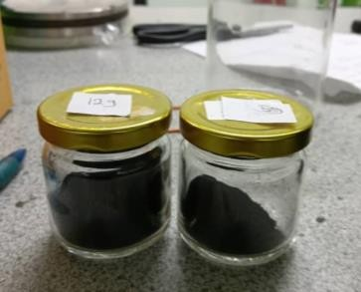
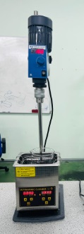
(b)
(a)
Figure 1: (a) N330 carbon black, (b) Blending process of carbon black and B20+lubricant using overhead stirrer
2.2 Sample Elastomer Preparation
Three types of elastomers were used: Nitrile Butadiene Rubber (NBR), Ethylene Propylene Diene Monomer (EPDM), and Chloroprene Rubber (CR) for evaluation due to their common usage in automation systems such as hoses, seals, and pistons. Each elastomer sheet was obtained, with a thickness of 3 mm and a dimension of 300 mm x 300 mm. Each elastomer was precisely cut into two distinct shapes based on the testing requirements, followed by the immersion process, which included tensile strength and hardness tests. For the tensile strength, the elastomer sheets were cut into dog-bone shapes following the ASTM D412 standard Figure 2. This standard is specifically introduced for evaluating the tensile properties of rubber and other elastomeric materials. For the hardness test, the elastomer sheets were cut into square shapes with dimensions of 20 mm x 20 mm, following the ASTM D2240 standard, which is largely used for testing the hardness of soft, flexible materials like rubber.

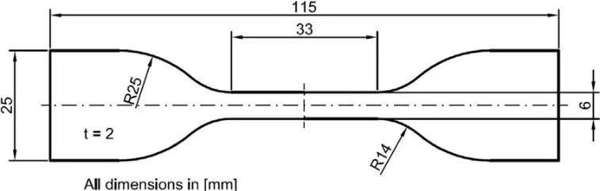
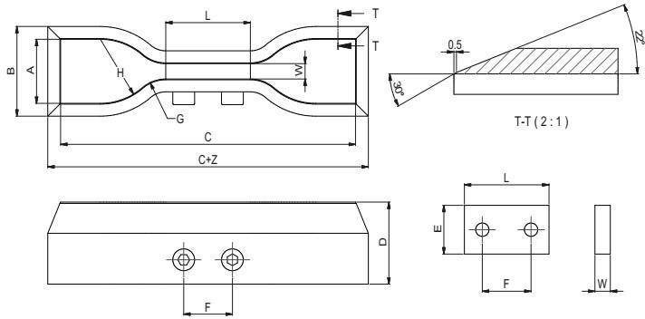
Figure 2: Dog-bone shape for tensile strength according to ASTM D412 method
2.3 Immersion process
For the immersion test apparatus, all of the elastomer samples were hung vertically on strings to a wooden support rod such that every sample was fully submerged in the test fluid without contact with the bottom or side of the beaker, as shown in Figure 3. The suspended specimens were immersed in the 500 ml glass beakers, with different concentration of carbon black. These beakers were then sealed with an airtight seal of plastic wrap as shown in Figure 3 and covered with aluminium foil to limit oxidation, evaporation, and contamination from the surrounding environment throughout the immersion period of 1,152 hours mimicking long-term exposure situations that are frequently found in actual fuel systems. This controlled immersion period enabled the evaluation of biodiesel degradation effects and potential chemical interactions with the elastomer materials over time.
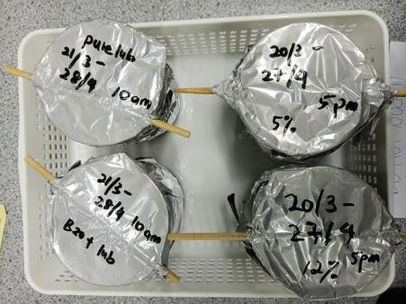
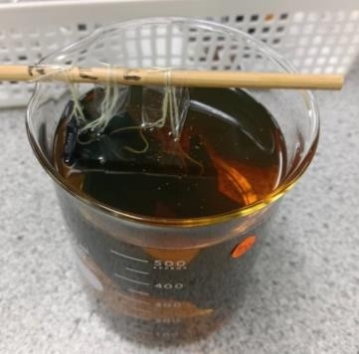
(a)
(b)
Figure 3: (a) Elastomers immersed in fuel (b) beakers contain immersed elastomers and covered with aluminum foil
2.4 Physicochemical testing of fuel blends
The physicochemical testing of fuel blends was tested at the end of the immersion period against kinematic viscosity, total acid number (TAN) and water content determination.
2.4.1 Kinematic Viscosity
Kinematic Viscosity is a critical property that influences the characteristics of fuel flow and injector performance. Any increase in viscosity level may indicate oxidation, polymerization, or contamination in the fuel. To complete this test, an 80 ml sample of each biodiesel blend was collected and analysed to evaluate changes in viscosity post-immersion according to ASTM D445 standard.

2.4.2 Total Acid Number
Increased acidity in biodiesel could be a sign of oxidation, breakdown, or the presence of free fatty acids, which can hasten elastomeric material deterioration and corrosion. The ASTM D974 standard, a generally recognized technique for assessing the acidity of petroleum products and blends of biodiesel, was followed in the conduct of this analysis. Every sample was examined separately, and precautions were taken to prevent contamination between tests. After 1,152 hours of elastomer immersion, this process was crucial for determining each contaminated biodiesel blend's degree of oxidation and chemical degradation.
2.4.3 Water Content
Excess water content can lead to hydrolysis and microbial activity, which may influence the speed of the degradation of the elastomers used in automotive systems. The water content in biodiesel-lubricant blends is a crucial factor, influencing the stability of the chemical composition and compatibility with elastomers. The test was done according to ASTM D6304 using coulometric Karl Fischer.
2.5 Mechanical testing
2.5.1 Hardness Test
A hardness test was performed on the square-shaped elastomer specimens using a Shore A Durometer, followed by the ASTM D2240 standard, which is compatible with softer materials such as rubber. This test was conducted by placing the specimens on a flat and hard surface. The durometer was used to press vertically onto the specimens to ensure a precise and accurate reading. The test was done pre and post immersion process.
2.5.2 Mass Change Evaluation
Each specimen’s mass was measure before and after immersion using a precision balance, focusing on the mechanical testing to calculate the percentage of mass change influenced by the immersion process. This data provides insight into how each elastomer specimen absorbs in response to when exposed to various biodiesel-lubricant blends.
2.5.3 Tensile Strength
The tensile strength of the elastomer specimens was evaluated using dogbone-shaped samples, followed by the specifications outlined in ASTM D412, a test method to highlight the tensile properties of rubber and elastomeric materials (Figure 3). Each specimen was securely clamped into the grips of the Universal Testing Machine (UTM) as shown in Figure 4, and the dimensions of the specimen were entered into the machine’s software interface. The test was carried out at a crosshead speed of 500 ± 50 mm/min, following the ASTM D412 standard, until the specimen was ruptured.
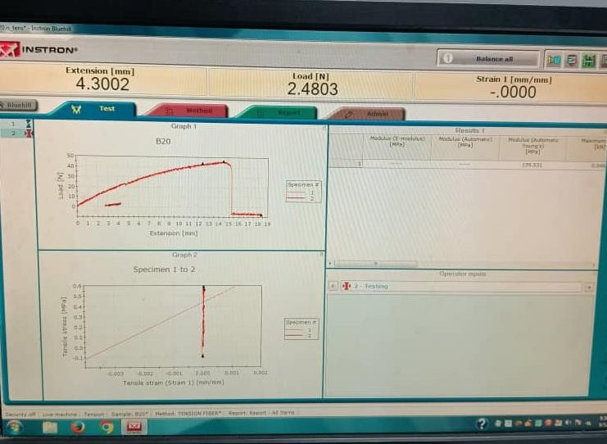
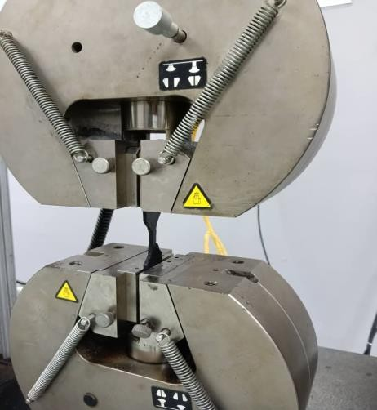
(b)
(a)
Figure 4: (a) Universal Testing Machine (UMT), (b) Instron Software to record the tensile critical parameters

3.0 RESULTS AND DISCUSSION
The study presents the effects of contaminated biodiesel-lubricant blends on fluid properties and elastomer performance after 1152 hours of continuous immersion.
3.1 Physicochemical analysis
The viscosity measurement at 40°C and 100°C shows that the biodiesel-lubricant blend consistently exhibited the highest viscosity while pure lubricant recorded the lowest. However, introducing carbon black to biodiesel-lubricant blends increase the oil viscosity. All blends experiencing a significant reduction in viscosity as temperature increased. This is consistent with the general behaviour of fluids becoming less viscous at higher temperature [5].
The total acid number (TAN) and water content increases markedly [4][6] with the presence and concentration of carbon black in biodiesel blends. B20-lubricant blend with presence of 12% carbon black recorded the highest TAN (11.56 mg KOH/g) and water content (0.305 wt%), indicating severe oxidative degradation, whereas B20-lubircant showed the lowest and most stable TAN and moisture levels. Visual colour changes (yellowish, pinkish, greenish and opaque black) further support the occurrence of oxidation, acid formation and particulate contamination (Figure 5).
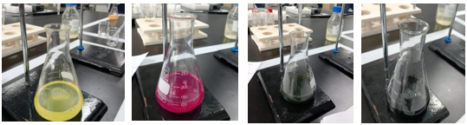
(d)
(c)
(b)
(a)
Figure 5: Visual color changes in biodiesel-lubricant samples (a) pure lubricant, (b) B20+lubricant, (c) B20+lubricant+5% cb, (d) B20+lubricant+12% cb
3.2 Mechanical testing analysis
From the elastomer perspective, all three materials (NBR, EPDM and CR) experienced substantial changes in mass, hardness and tensile strength, though to varying degrees. The impact of each fuel blend on elastomers specimens was assessed through changes in mass (indicative of absorption, swelling or degradation), hardness (Shore A, ASTM D2240 for surface integrity) and tensile strength (ASTM D412 for mechanical performance).
3.2.1 Mass change
In the square specimens used for hardness testing, the percentage mass change showed distinct differences in elastomer response to the biodiesel–lubricant blends as shown in Figure 6. NBR recorded the highest swelling in the 5% carbon black blend (44.72%), demonstrating its strong sensitivity to hydrocarbon-rich and contaminated environments. The presence of carbon black likely enhanced fuel and moisture diffusion into the polymer matrix, especially at the lower 5% concentration where the blend remained less saturated than the thicker 12% mixture.
EPDM exhibited its maximum swelling in the B20-lubricant blend (35.81%), confirming its high susceptibility to biodiesel and lubricant absorption. The notably greater swelling in clean B20 compared to carbon-black-containing blends suggests that particle agglomeration or increased viscosity may partially restrict fuel penetration. Nonetheless, EPDM’s significant dimensional changes across all blends including the lubricant condition indicate poor chemical resistance and unsuitability for long-term service in biodiesel–lubricant environments.
Conversely, CR maintained low and steady mass changes in all blends, with swelling not exceeding 24.87%. This behaviour highlights CR’s superior resistance to absorption and oxidative degradation, attributed to its chlorine-containing backbone, which offers enhanced chemical stability against biodiesel penetration.
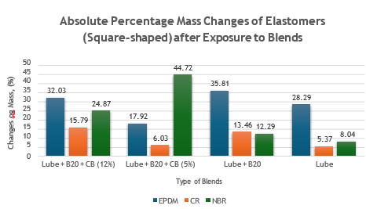
Figure 6: Mass change for all elastomers under all blends

3.2.1 Hardness test analysis
The hardness test (Figure 7) showed that all elastomers experienced surface softening after 1152 hours of immersion in biodiesel–lubricant blends, but the severity varied significantly among materials. EPDM suffered the most consistent and severe degradation, with hardness reductions of up to 43–44%, especially in blends containing B20 and carbon black. Its strong sensitivity to biodiesel’s polar ester components, high TAN, and moisture levels caused extensive softening, indicating very poor chemical resistance. NBR also showed major hardness loss—over 50% in the 12% carbon black blend and nearly as high in the 5% blend—reflecting its vulnerability to oxidized biodiesel, acidic by-products, and moisture-driven degradation. In contrast, CR maintained the highest hardness retention across all blends, with reductions generally below 30%, and as low as 7% in the pure lubricant condition. This resilience is attributed to its chlorine-containing polymer structure, which provides superior oxidative and thermal stability. Overall, EPDM and NBR are significantly weakened by biodiesel contamination, while CR remains the most chemically and mechanically stable elastomer for prolonged exposure to biodiesel–lubricant environments.
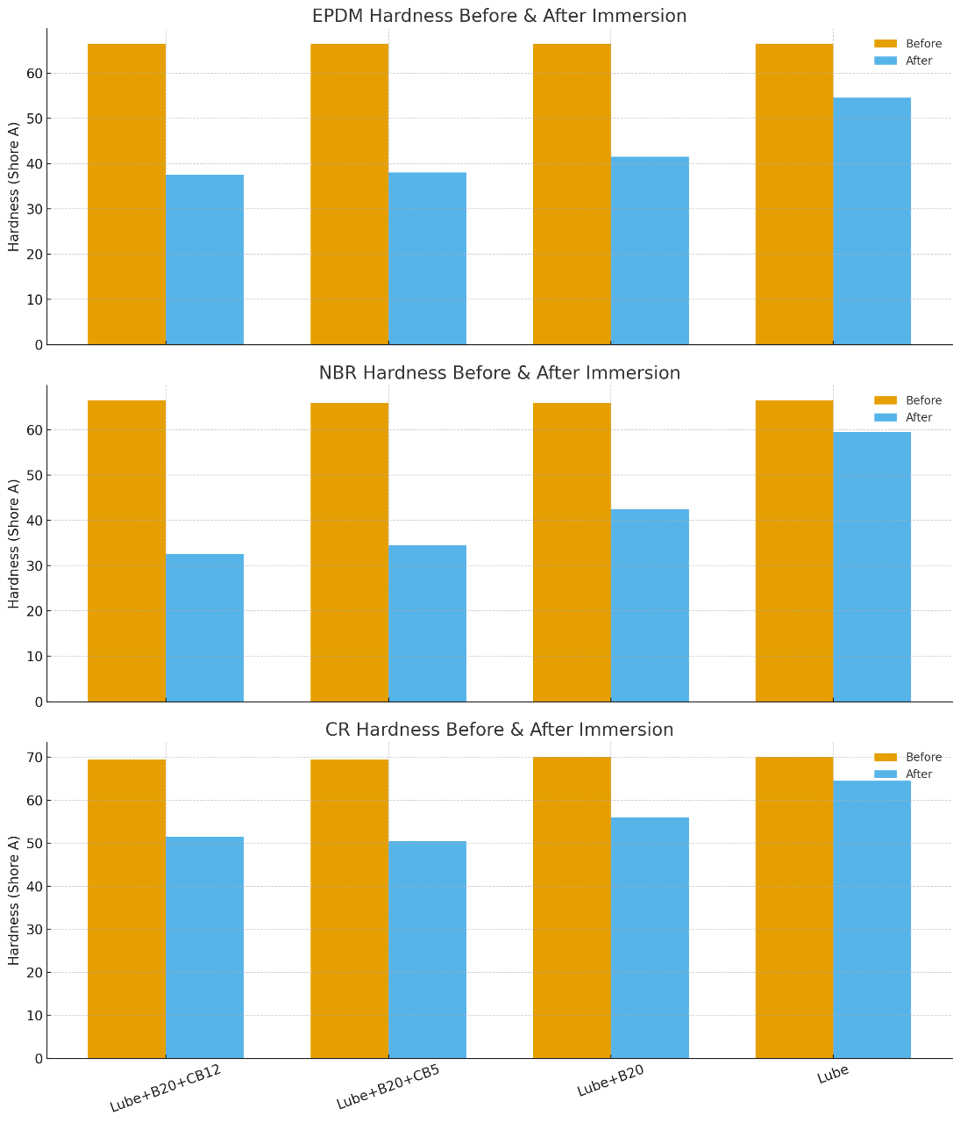
Figure 7: Hardness test before and after immersion
3.2.2 Tensile test analysis
Tensile testing revealed that all elastomers experienced substantial mechanical degradation after 1152 hours of immersion in biodiesel–lubricant blends, with the severity varying between materials and contaminant levels (Figure 8). EPDM, which initially had a tensile strength of 5.58 MPa, suffered the most severe deterioration—losing 75–78% of its strength in all biodiesel-containing blends and 58.7% even in pure lubricant. This indicates that EPDM is highly unstable in fuel-lubricant environments, with biodiesel’s polar esters, high TAN, and moisture accelerating chain scission and crosslink breakdown.
NBR, initially the strongest elastomer at 7.37 MPa, also showed major strength loss after immersion. Tensile strength dropped by 69–70% in both 5% and 12% carbon black blends, and by 79.6% in the B20 + Lube blend—demonstrating NBR’s strong susceptibility to biodiesel-induced swelling, oxidation, and hydrolysis. Even in the Lube-only blend, NBR still lost 68.8% of its original strength, confirming limited compatibility even in non-biodiesel fluids when exposed long-term.
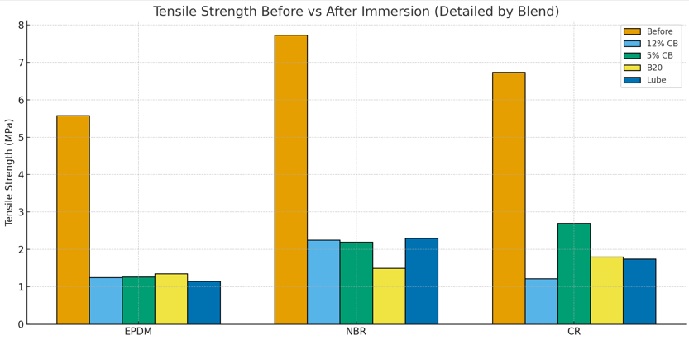
Figure 8: Tensile Stress before and after immersion
Overall, both EPDM and NBR experienced extensive mechanical deterioration across all blends, driven by biodiesel diffusion, contaminant-induced oxidation, and moisture-related degradation. The results confirm that these elastomers are poorly suited for long-term service in biodiesel-exposed environments, where tensile strength retention is critical for seal durability and reliability [7].
3.3 Discussion
The results of this study are consistent with existing literature showing that biodiesel is highly susceptible to oxidation, moisture absorption, and particulate-induced degradation. Biodiesel–lubricant systems are known to absorb more water than petroleum diesel, which accelerates hydrolysis, acid formation, and corrosion; similar hygroscopic behaviour has been widely reported [6]. The presence of soot or carbonaceous particulates further intensifies oxidative instability, as soot-contaminated biodiesel and lubricating oils demonstrate elevated TAN, higher water retention, and accelerated chemical breakdown [8][9]. These contaminants promote the formation of peroxides, acids, and polymerised by-products, all of which contribute to increased chemical aggressiveness within the fuel matrix. Such oxidative and particulate-driven degradation directly compromises elastomer performance, as previously shown in the degradation of carbon-black-filled NBR exposed to biodiesel-derived fuels [10] and in studies demonstrating elasticity loss, swelling, and mechanical weakening in biodiesel-aged elastomers [7][11]. Overall, literature strongly supports the observed behaviour in this work: contaminated biodiesel-lubricant blends particularly those with high TAN, moisture content, and particulate loading—create an aggressive environment that accelerates elastomer deterioration and poses a risk to long-term material compatibility in biodiesel-fuelled systems.
4.0 CONCLUSION
This study evaluated the degradation of NBR, EPDM, and CR when exposed to contaminated B20 biodiesel-lubricant blends containing carbon black. All three elastomers experienced severe tensile strength reduction after immersion, confirming that prolonged exposure to biodiesel-lubricant blends and contaminants significantly degrades mechanical performance. EPDM and NBR lost more than 75% of their strength in most conditions, demonstrating poor compatibility with biodiesel-based systems. Although CR also degraded, it retained notably higher strength in the 5% carbon black blend, indicating superior resilience. Overall, CR is the most suitable elastomer for biodiesel-lubricant applications, while EPDM and NBR should be avoided in environments where seal reliability and mechanical integrity are critical.
ACKNOWLEDGEMENT
The authors would like to thank Universiti Teknikal Malaysia, Melaka and the Ministry of Education, Malaysia, for the use of laboratory equipment’s. The author also would like to thank Puan Nor Hidayah binti Rosli for the guidance in Tribology’s Laboratory and Oil Analysis Laboratory at Faculty of Technology and Mechanical Engineering for assistance in conducting the machine.

REFERENCES
[1] Knothe, G., & Van Gerpen, J. (Eds.). (2005). The Biodiesel Handbook (1st ed.). AOCS Publishing.
[2] Knothe, G. (2010). Biodiesel and renewable diesel: A comparison. Progress in Energy and Combustion Science, 36(3), 364–373
[3] Ogunkunle, O., & Ahmed, N. A. (2021). Overview of biodiesel combustion in mitigating the adverse impacts of engine emissions on the sustainable human– environment scenario. Sustainability, 13(10), 5465.
[4] Chandran, D., Ng, H. K., Nang, H., Gan, S. Y., Choo, M., & Jahis, S. (2016). Compatibility of biodiesel fuel with metals and elastomers in fuel delivery system of a diesel engine. Journal of Oil Palm Research, 28(1), 79–90.
[5] Nie, Z., Li, F., Sui, M., Wang, S., Han, G., & Liu, Z. (2015). Effect of temperature on the kinematic viscosity of biodiesel fuels. In Proceedings of the 5th International Conference on Energy and Environmental Protection (ICEEP 2015) (pp. 24–28). Atlantis Press.
[6] Fregolente, P. L. G., Fregolente, L. V., & Maciel, M. R. W. (2012). Water content in biodiesel, diesel, and biodiesel–diesel blends. Journal of Chemical & Engineering Data, 57(6), 1817–1821.
[7] Sjöstedt, C., Akhlaghi, S., Pourrahimi, A. M., & Hedenqvist, M. S. (2017). Effects of ageing conditions on degradation of acrylonitrile butadiene rubber in rapeseed biodiesel. Polymer Degradation and Stability, 137, 130–141.
[8] Oungpakornkaew, P., Karin, P., Tongsri, R., & Hanamura, K. (2020). Characterization of biodiesel and soot contamination on four-ball wear mechanisms using electron microscopy and confocal microscopy. Wear, 478, 203407
[9] Motamen-Salehi, F., Riahi, A., & Khajepour, S. (2017). The effect of soot and diesel fuel contamination on wear and friction of an engine oil pump. Tribology International, 114, 272–279.
[10] Akhlaghi, S., Pourrahimi, A. M., Hedenqvist, M. S., & Sjöstedt, C. (2015). Degradation of carbon-black-filled acrylonitrile butadiene rubber in alternative fuels: Transesterified and hydrotreated vegetable oils. Polymer Degradation and Stability, 123, 57–68.
[11] Hu, Z., Lin, C., et al. (2021). Interactions between used cooking oil biodiesel blends and elastomer materials. Renewable Energy, 175, 1070–1082.

